ej 14 . orinakner vortexa petq avtomat teoremi apacucumy.
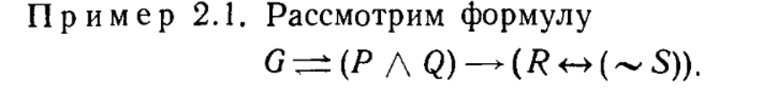
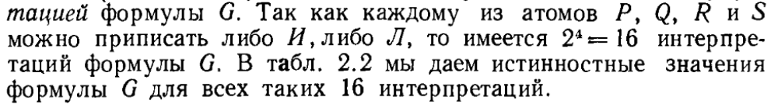
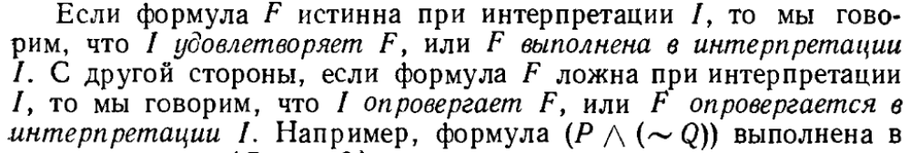
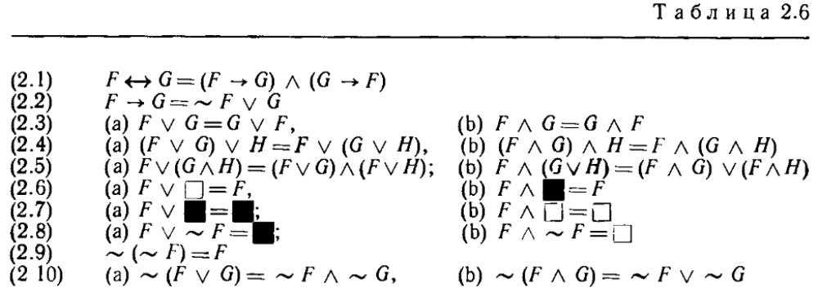
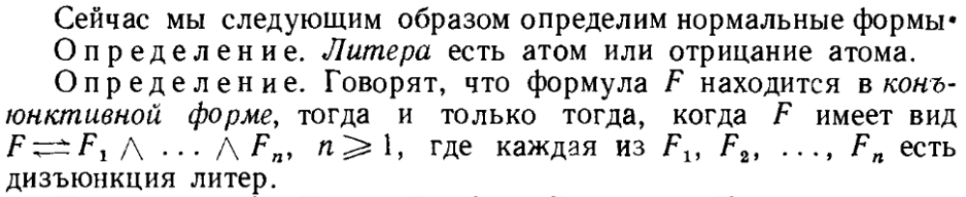
Ej 26
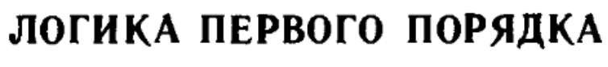ej 36
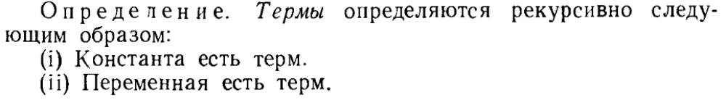
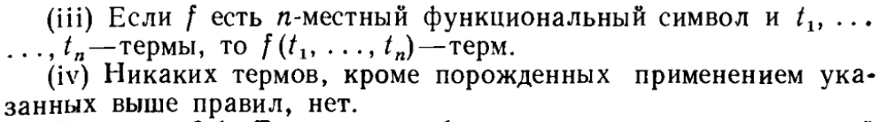
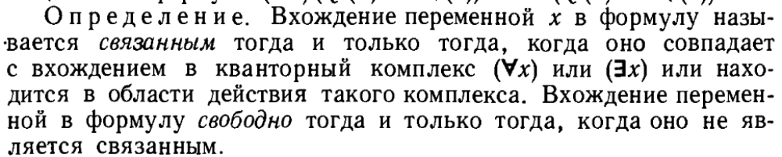
Ej 39 – inch e formulan
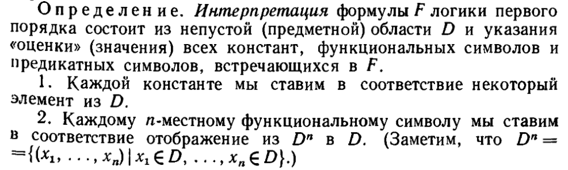
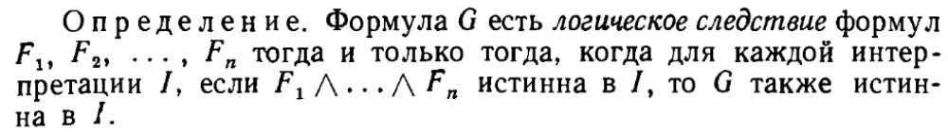
Mnacac sra nmannery nuyn dzev.
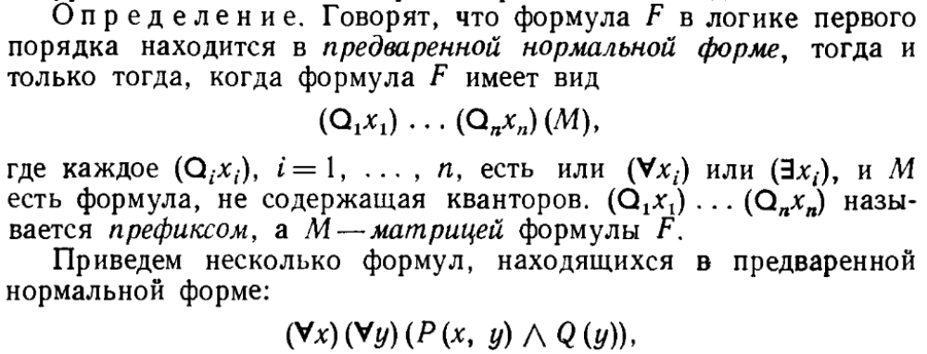
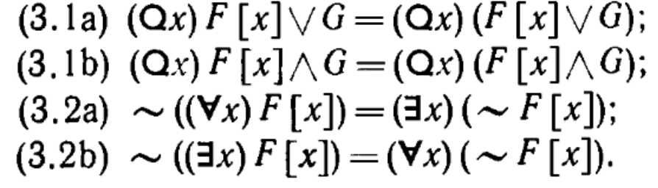
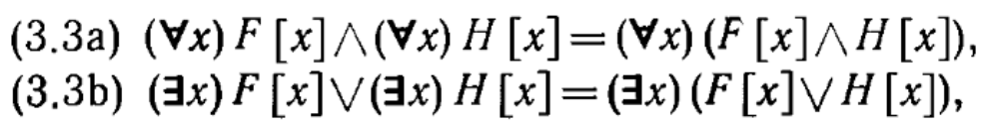
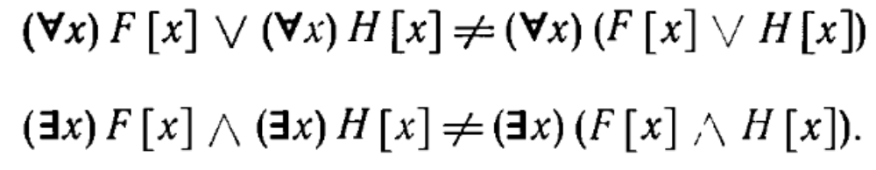
Verjnakan tesqy nerqevum` sranq ogtagorcvum en vor havasarumy normal tesqi bervi . ej 47
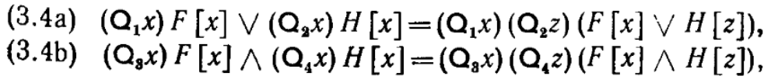.
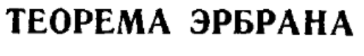
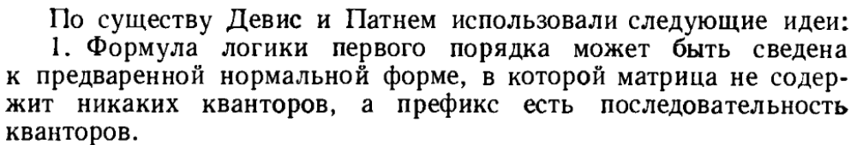
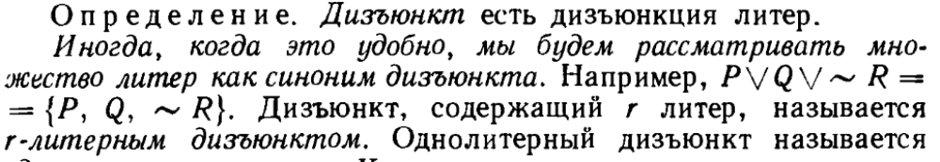
Kisat..
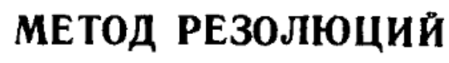
Ej 78.
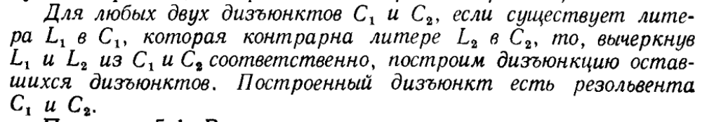
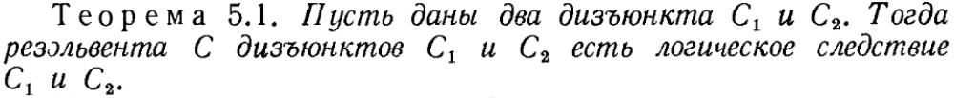
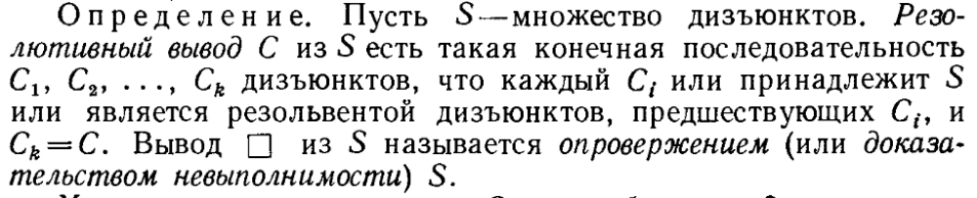
ej 81
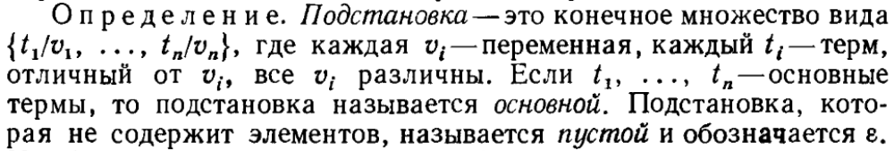
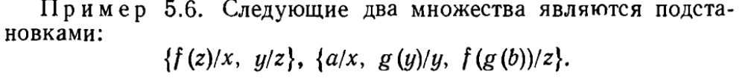
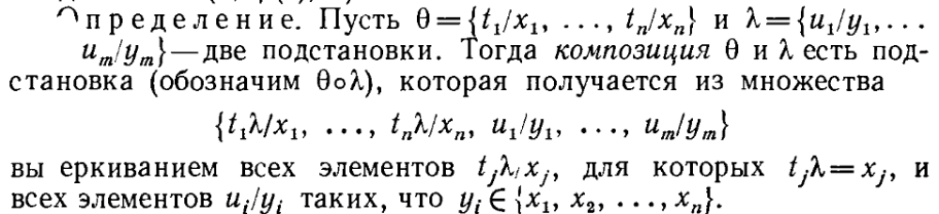
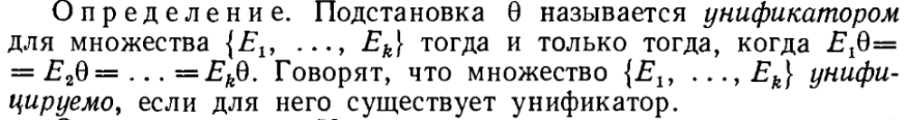
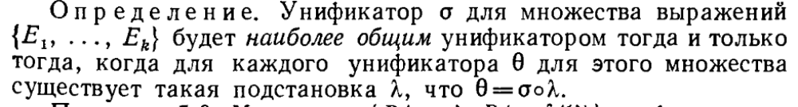
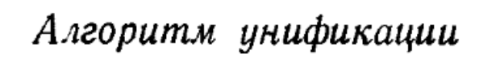ej 83. Orinak ej 84
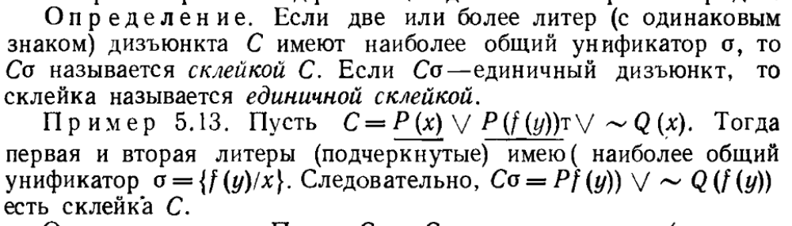
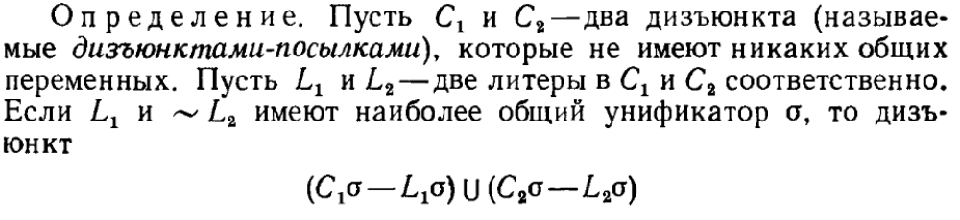orinak ej 86. Ej 88-I orinakum menq herqum(jxtum) enq teoremy u cucy talis vor ayd herqvacy anluceli e(hasnelov datark dizunkti). Naey ej 92-ic.(orinakner)
Ej 88-ic sksuma resolutiayi lrivutyan apacuycy.
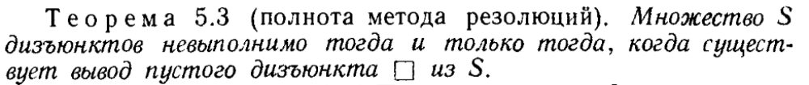
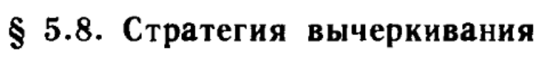ej97. vorovhetev ete tanq cragrin u inqy hertov bolori hamar resolutia ani liqy ankap dizunkntner en I hayt galis voronq petq chen.
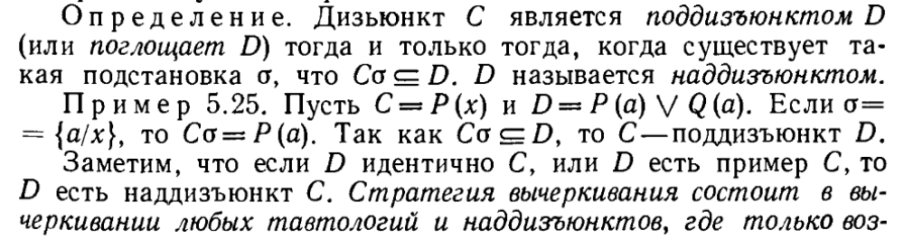
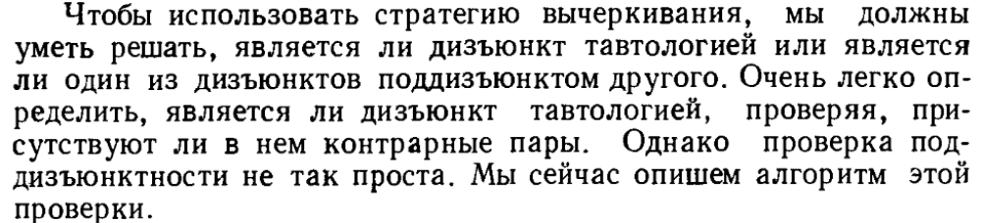
Orinaknery lav chhaskaca. Resoluciayi 3 stategianery.`
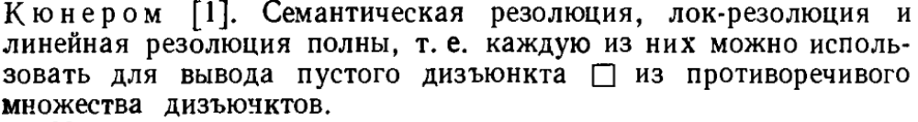

$$P(a)→\sim ((∃x)P(x))$$
$P\left(x\right)⋁R\left(y\right), ¬R\left(a\right)⋁Q\left(z\right) P\left(x\right)⋁Q\left(z\right) σ\{y/a\}$

